

VILNIUS UNIVERSITY
SIAULIAI ACADEMY
BACHELOR PROGRAMME SOFTWARE ENGINEERING

SYSTEM APPLICATIONS AND PRODUCTS IN DATA PROCESSING (SAP)

E-service Design Principles and Infrastructure Solutions. Practical Work № 10

Student :
Lecturer: Prof. Dr. Dale Dzemydiene

Siauliai, 2023

PP 1: Display Stock/Requirements List
Exercise: Use the SAP Fiori Launchpad to display the Stock/Requirements List.

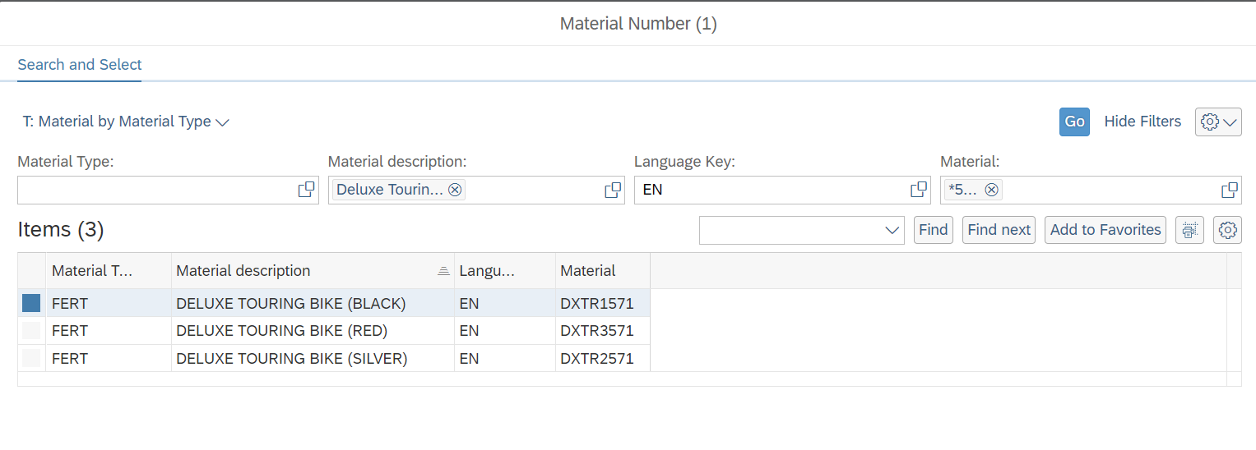
There is list with finished goods, names that start with the Touring Bike and material numbers that ends with my number 571.
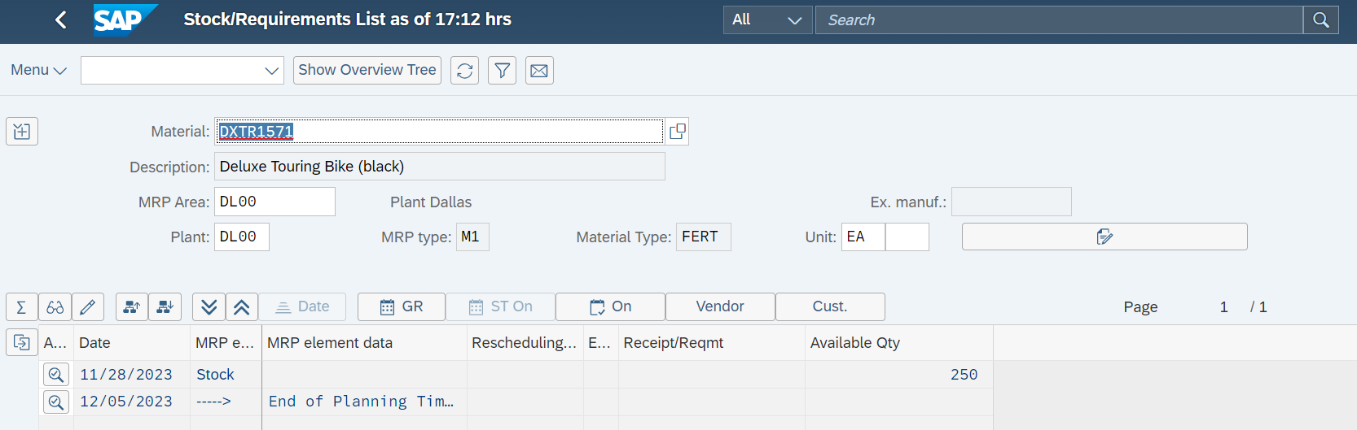
Next I check all bikes in stock
0 red Deluxe Touring Bikes are available in Dallas
0 silver Deluxe Touring Bikes are stored in the DL00 plant
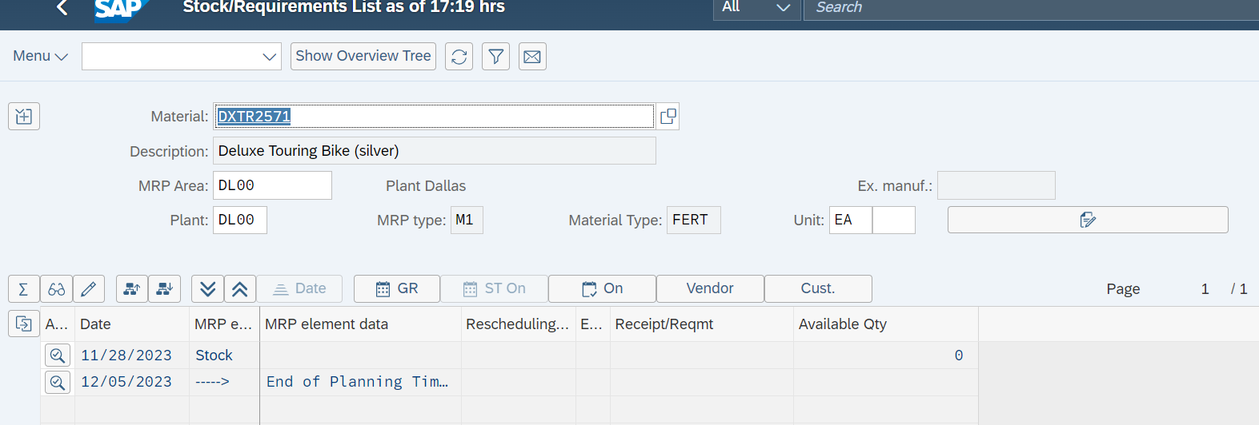

PP 2: Display Bill of Material
Exercise: Use the SAP Fiori Launchpad to display a bill of material.
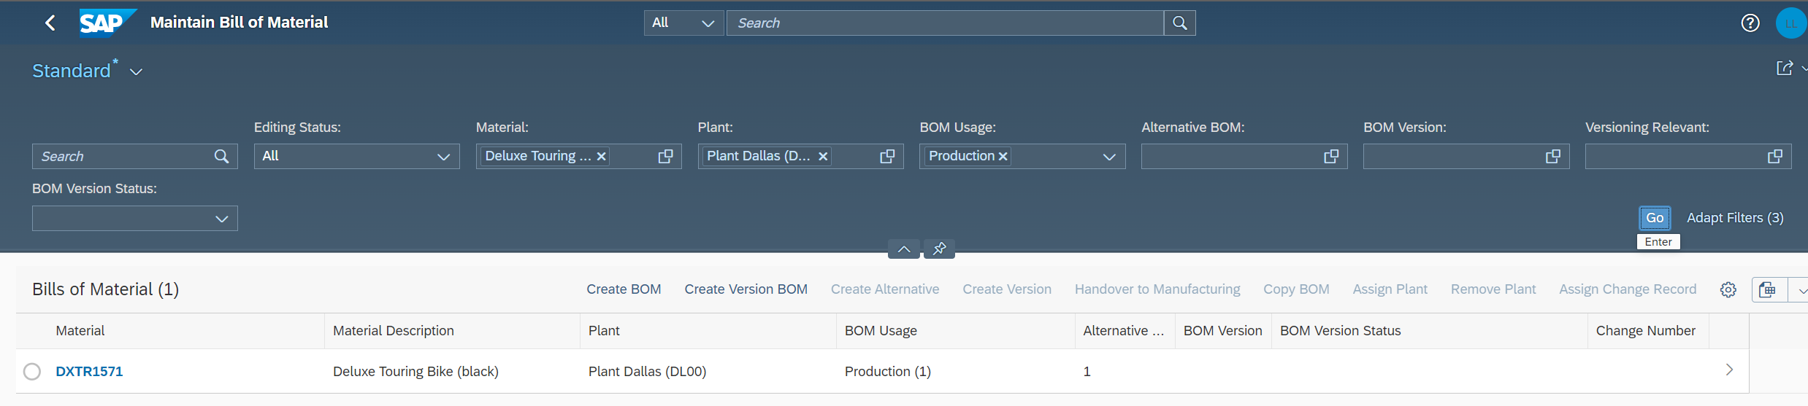
Now we checking bill of the material for TRWA1571
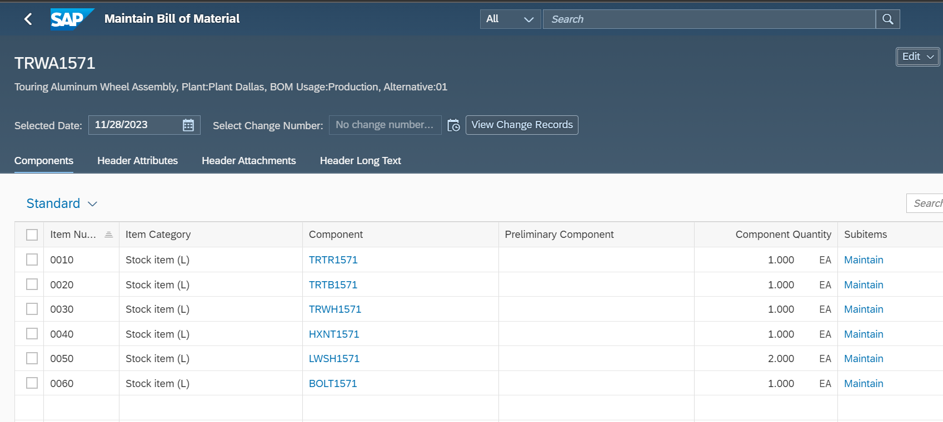
How many parts of the TRWA1## component are needed to manufacture the DXTR1##?
Answer: 6

PP 3: Display Multi-Level Bill of Materials
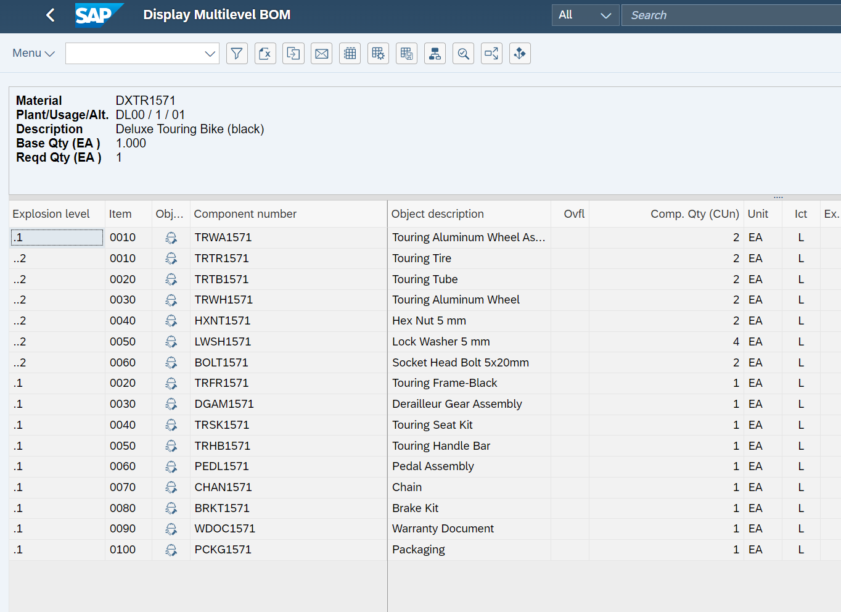
Exercise: Use the SAP Fiori Launchpad to display a multi-level BOM.
There we display the BOM structure for your bike valid today. There we can see summarized list of materials required for both the Deluxe Touring Bike (DXTR1571) and the Touring Aluminum Bike (TRWA1571).
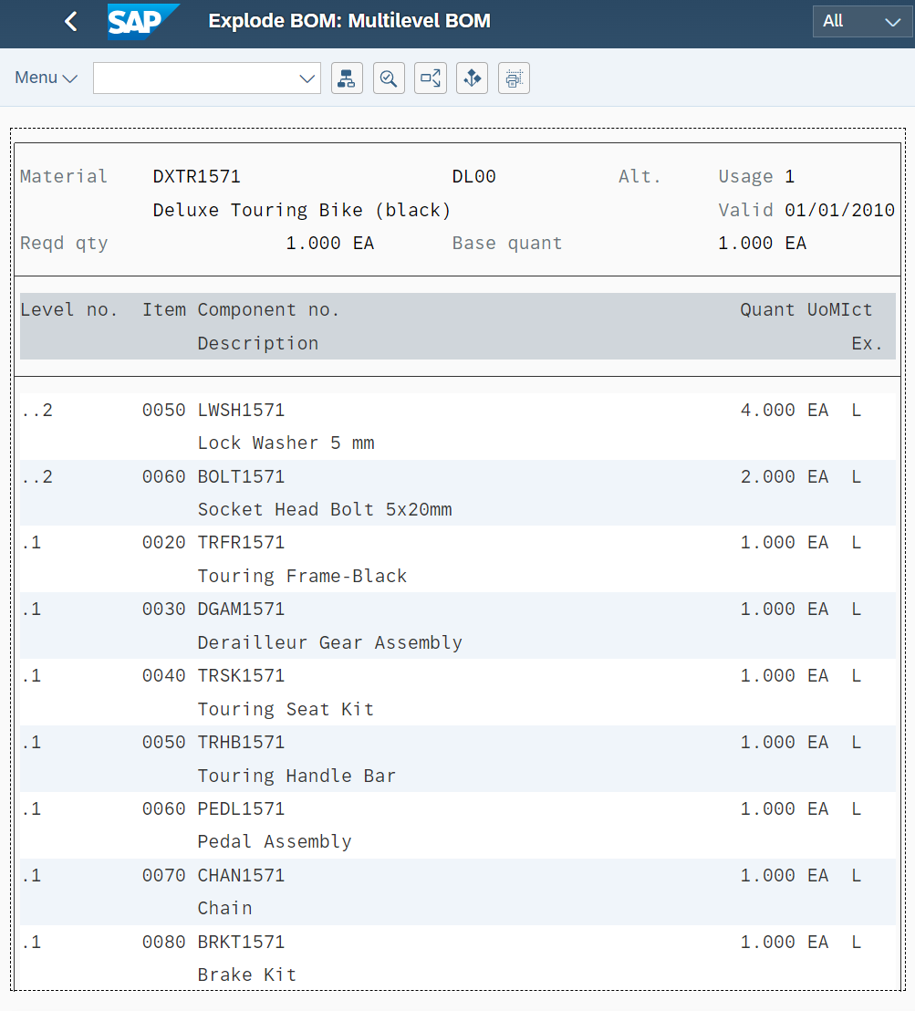

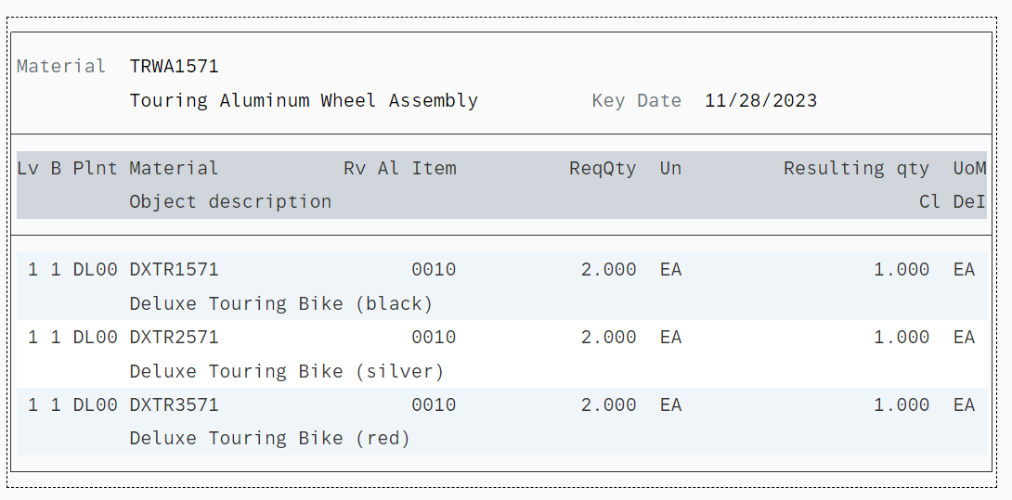
There will get an overview of all used items.

PP 4: Display Routing
Exercise: Use SAP Fiori Launchpad to display a routing.

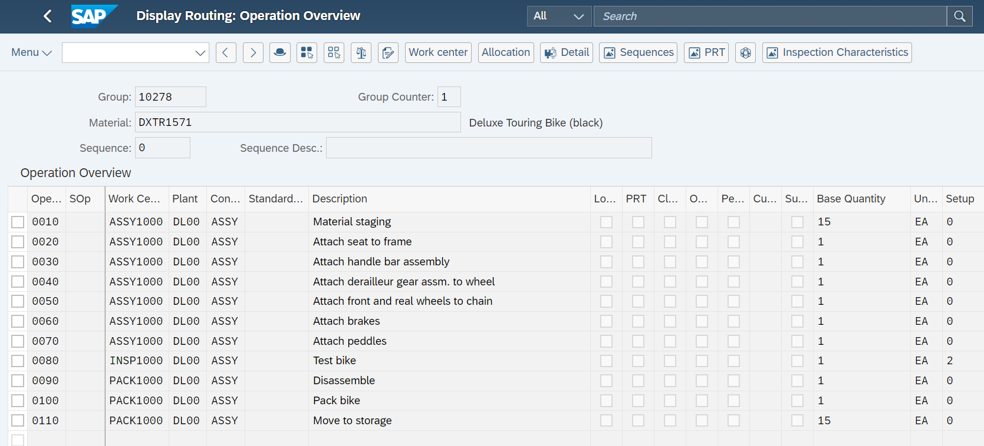
We go to the operation overview.

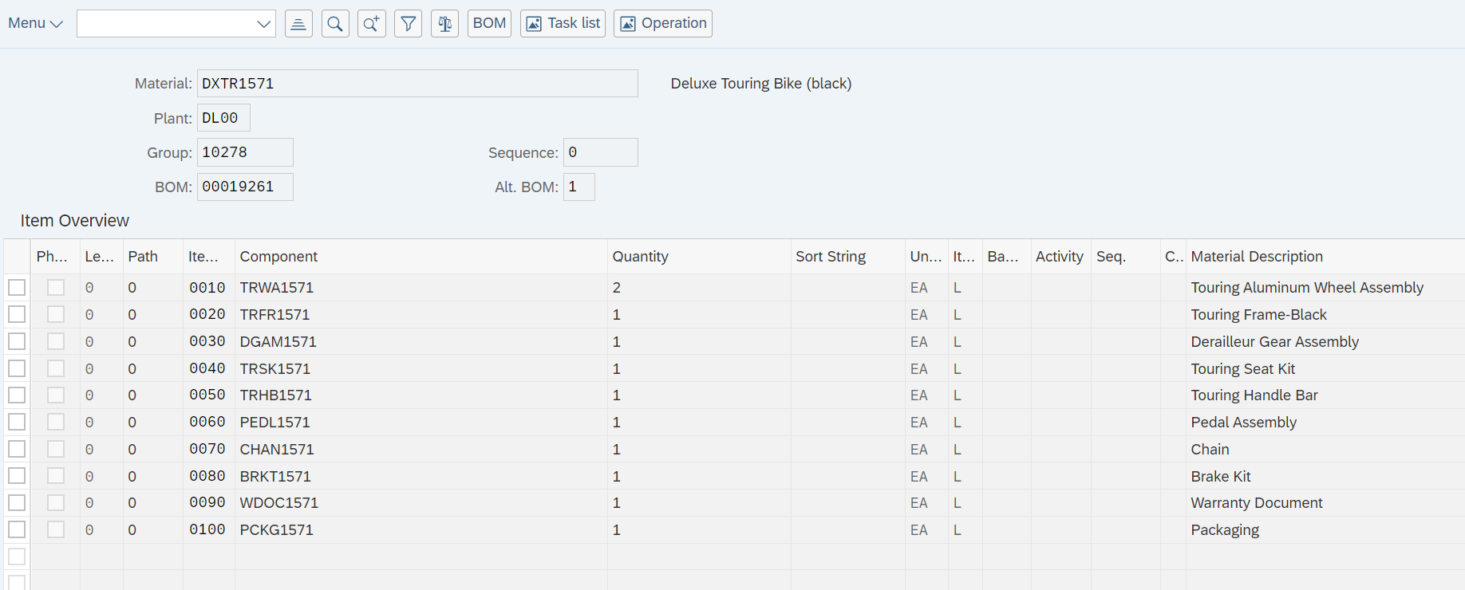

Then we go to the schedule. Choose 1 as a schedule type and 10 as a lot size.
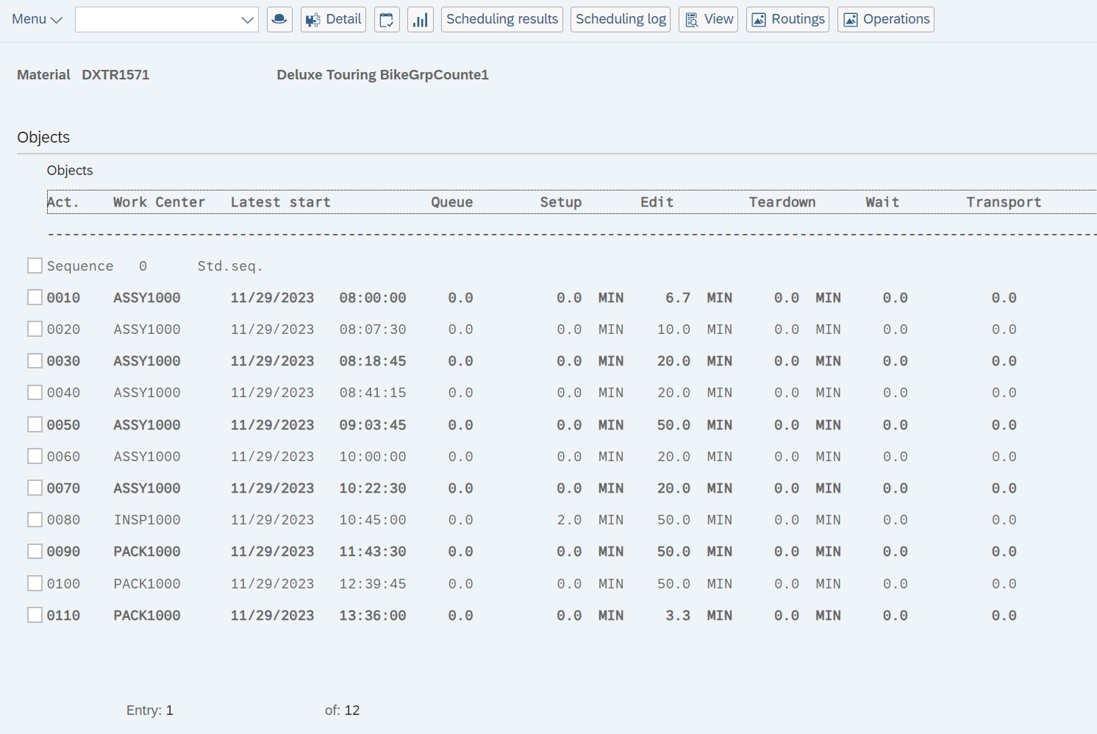
How long does sequence 0090 take?
Answer: 50 min
What is the total processing time?
Answer: 5 h

PP 5: Display Work Center
Exercise: Use the SAP Fiori Launchpad to display a work center
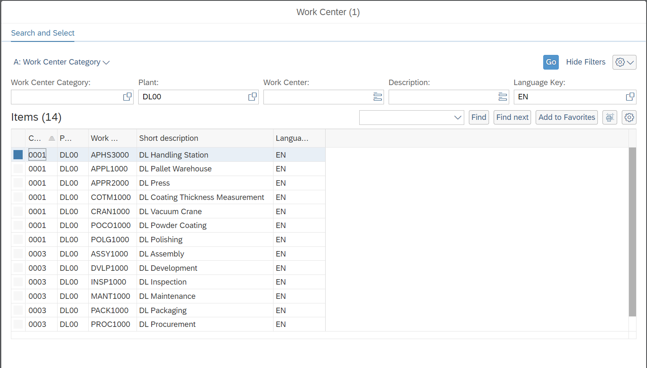
On the Basic Data tab, find out who is the person responsible
Answer: Steven Barton
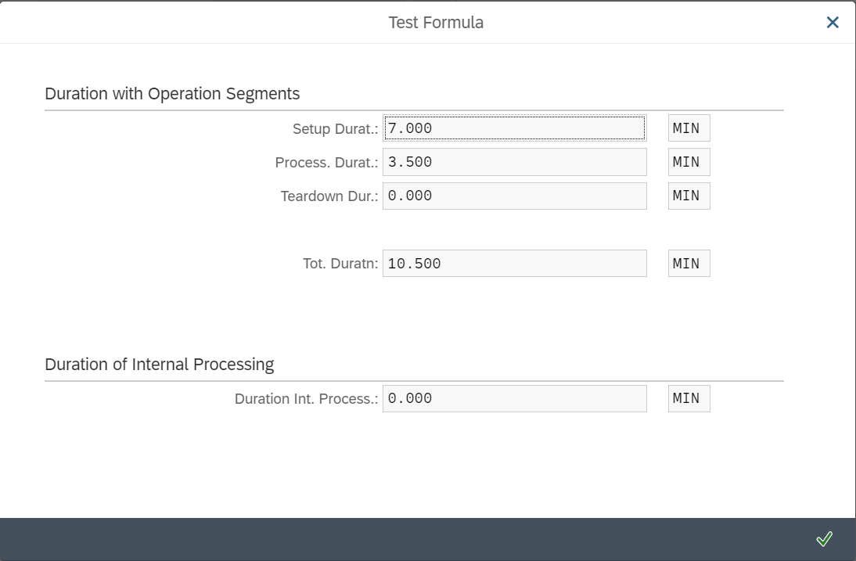
Did the Processing formula work correctly?
Answer: Yes

